ASSIGNMENT – 2

Python Programming

|  |  |
| --- | --- |
| Assignment Date | 25-09-2022 |
| Student Name | Ms . Roshini R |
| Student Roll Number | 717819f242 |
| Maximum Marks | 2 Mark |

# Question-1 :

1 . Importing Required Package Solution :

import pandas as pd import seaborn as sns import numpy as np

from matplotlib import pyplot as plt

%matplotlib inline

Question-2 :

1. Loading the Dataset Solution :

df = pd.read_csv("/content/Churn_Modelling.csv") df

Output:

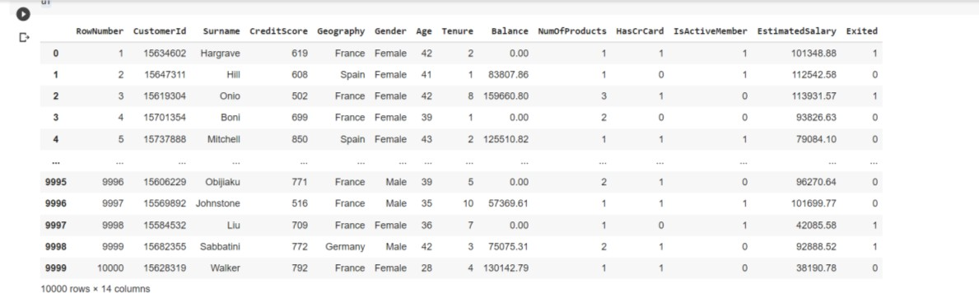

1. Visualizations

# Question-3 :

* 1. Univariate Analysis Solution:

sns.displot(df.Tenure)

Output:

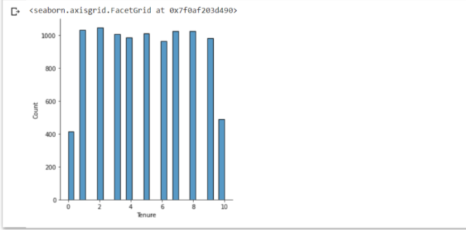

* 1. Bi-Variate Analysis Solution:

df.plot.line()

Output:

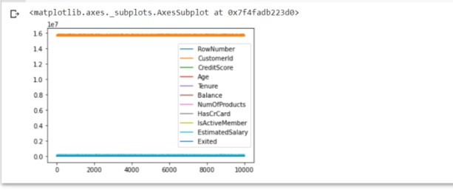

* 1. Multi - Variate Analysis Solution:

sns.lmplot("Age","NumOfProducts",df,hue="NumOfProducts", fit_reg=False);

Output:

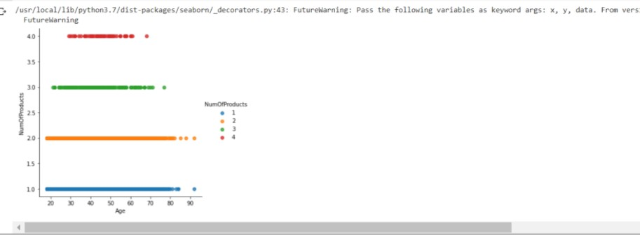

1. Perform descriptive statistics on the dataset.

# Question-4 :

Solution:

df.describe()

Output:

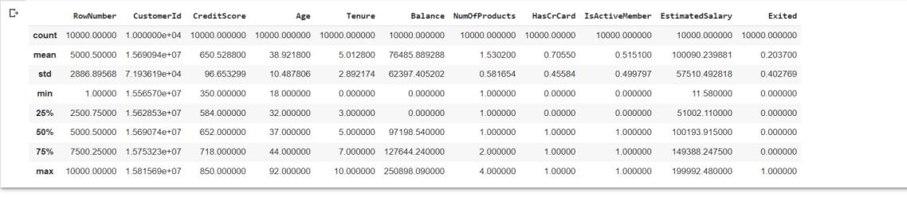

1. Handle the Missing values.

# Question-5 :

Solution:

data = pd.read_csv("Churn_Modelling.csv") pd.isnull(data["Gender"])

Output:

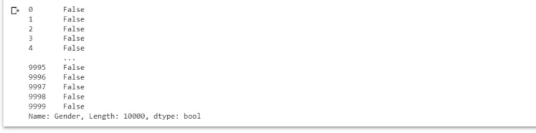

# Question-6:

1. Find the outliers and replace the outliers. Solution:

df["Tenure"] = np.where(df["Tenure"] >10, np.median,df["Tenure"]) df["Tenure"]

Output:

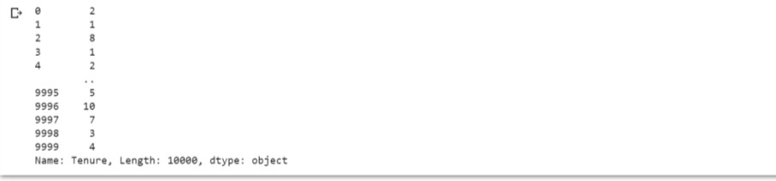

# Question-7 :

1. Check for Categorical columns and perform encoding. Solution:

pd.get_dummies(df, columns=["Gender", "Age"], prefix=["Age", "Gender"]

).head()

Output:

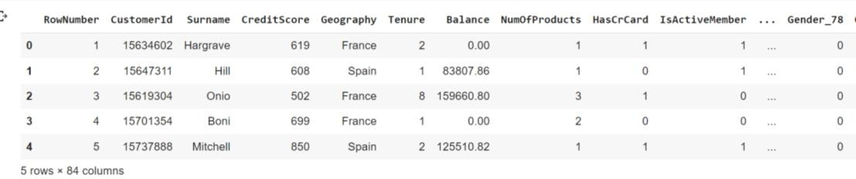

Output:

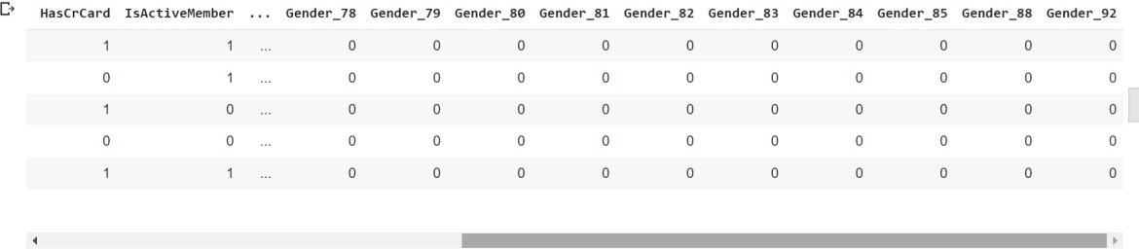

# Question-8:

1. Split the data into dependent and independent variables
   1. Split the data into Independent variables. Solution:

X = df.iloc[:, :-2].values print(X)

Output:

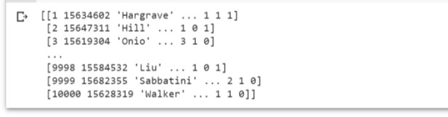

* 1. Split the data into Dependent variables. Solution:

Y = df.iloc[:, -1].values print(Y)

Output:



# Question-9 :

1. Scale the independent variables Solution:

import pandas as pd

from sklearn.preprocessing import MinMaxScaler scaler = MinMaxScaler()

df[["RowNumber"]] = scaler.fit_transform(df[["RowNumber"]]) print(df)

Output:

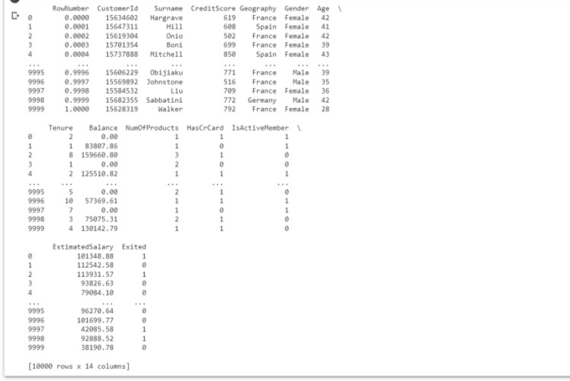

# Question-10 :

1. Split the data into training and testing Solution:

from sklearn.model_selection import train_test_split train_size=0.8

X = df.drop(columns = ['Tenure']).copy() y = df['Tenure']

X_train, X_rem, y_train, y_rem = train_test_split(X,y, train_size=0.8) test_size = 0.5

X_valid, X_test, y_valid, y_test = train_test_split(X_rem,y_rem, test_size=0. 5)

print(X_train.shape), print(y_train.shape) print(X_valid.shape), print(y_valid.shape) print(X_test.shape), print(y_test.shape)

Output:

